**Naik Hiong Chiang Week 4 Homework**

Files:

Week 4 Homework.py uses getimagenetclassesNewV2.

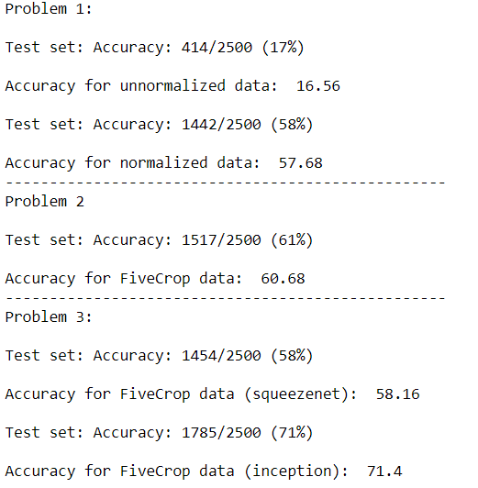

Consider the ten crop: this is five crop with vertical mirroring for five of the ten. For what datasets mirroring is a bad augmentation idea?

1. Heavily symmetrical data. With heavily symmetrical data, a mirroring would not affect the data, hence meaningless.
2. Datasets that cannot be mirrored. An example would be alphabets (sentences) or numbers where mirroring would result in data that does not make sense.

